- How many of the patients are male and female, respectively?
772 males, 940 females, respectively.
SELECT
Patient_Gender,
COUNT(*) AS Gender_Count
FROM
dbo.patients
GROUP BY
Patient_Gender;
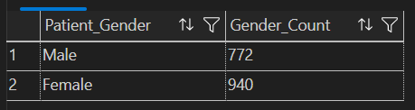
- What are the top 3 states where patients live?
Virginia, West Virginia, and Tennessee.
SELECT TOP 3
Patient_Address_State,
COUNT(*) AS Patient_Count
FROM
dbo.patients
GROUP BY
Patient_Address_State
ORDER BY
COUNT(*) DESC;

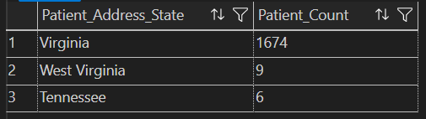
3.What are the ages of the youngest and oldest patients?
Youngest age: 3
Oldest age: 90
SELECT MIN(DATEDIFF(YEAR,Patient_Birth_Date,GETDATE())) as youngest
, MAX(DATEDIFF(YEAR,Patient_Birth_Date,GETDATE())) as oldest
FROM
dbo.patients

- How many patients got admitted to the hospital on 2023-03-18, and at what time was the latest admission that day?
- Patients were admitted to the hospital on 2023-03-18. The latest admission on 2023-03-18 was 23:48 or 11:48PM.
-- Tip: the date column experienced a problem with nulls during import. See if you can figure out what happened.
-- To resolve the issue, instead of CAST, use TRY_CAST(NULLIF([Encounter_Admit_Date], 'null') AS DATE)
SELECT
COUNT(*) AS Admissions_On_2023_03_18,
MAX(Encounter_Admit_Date) AS Latest_Admission_Time
FROM
dbo.encounters
WHERE
TRY_CAST(NULLIF(Encounter_Admit_Date, 'null') AS DATE) = '2023-03-18';


